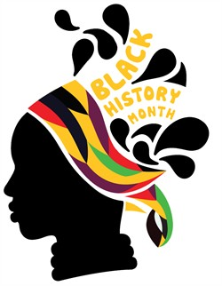
Through-out October 2015
Music Workshops Interactive-talks Arts & Crafts
Through-out October Diversity House will be holding workshops within the community and schools. If you are a business owner and would like to be a part of this please get in touch with us.
Black women in history - the spotlight on the contributions of black women
Black history – enrichment
The history of blacks in Britain

Phone: 01795 420455
Email:info@diversityhouse.org.uk
Address: Phoenix House, Central Avenue, Sittingbourne, Kent, ME10 4BX

